QUOTATION

TO: Bend Data Center QUOTE# 13744
Attn: Mr. Mark Klein
130 NW Greenwood SALES: Joe
Bend, OR 97701
DATE: January 10, 2003
TEL: 541-312-4251
FAX: TERMS: COD
E-mail: mklein@nmedia.net SHIPPING: UPS Ground

Standalone Access Control Proximity Card Readers
DESCRIPTION | QTY | EACH | AMOUNT
PR-30C Standalone Proximity Reader  (Indoor use, read range: up to 4”)  PR200 Proximity Reader (outdoor, read up to 4”)  JPC-200 Controller (control 1 PR200 reader) | 6  1  1 | $299.00  $180.00  $300.00 | $1,794.00  $180.00  $300.00
Employee Proximity Cards  (or Proximity Key-tag: $3.50 each) | 20 | $2.50 | $50.00
First 3 month phone support included.
APPROVAL SIGNATURE & DATE: |  | SUBTOTAL | $2,324.00
 |  | SHIPPING | $26.00
 |  | TAX | $0.00
__________________________________ |  | TOTAL | $2,350.00

Note:
- To order, please fax signed approval to 626-350-3238. Thank you.
- This quote is good for 60 days. 180-day manufacture warranty on hardware and software.
- Estimated time: within 2 weekS of order receipt.
- Jantek is not liable under any circumstances for loss or damage caused by or partially caused by misapplication or malfunction of the product. Jantek’s liability does not extend beyond the purchase price of the product.
- Electric door strike: $39 each, Electromagnetic lock: $139 each. Exit button: $29 each. Electric lock power supply: $15. Keyswitch: $42 each.
- Different door uses different kind of electric lock. Consult a local locksmith about the installation of electric lock.

PR-30C Standalone Proximity Access Control Reader

- Self-contained, Program from Built-in Keypad.
- Maximum Read Range: up to 4”
- User Capacity: 9,999 Cards (or KeyTags)
- Easy to Program and Install
- Size: 5.1” x 3.4” x 1”

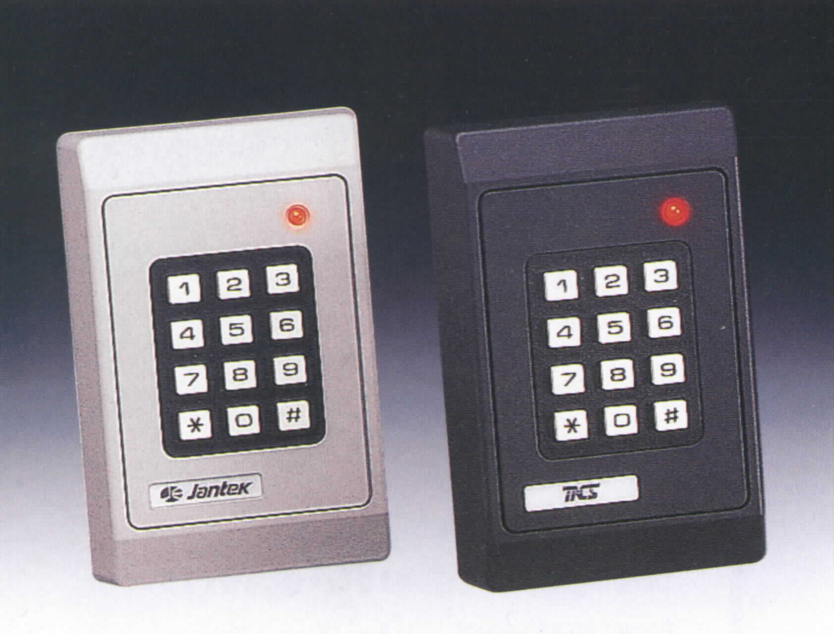

PR-30C is a state of the art standalone access control card reader system. It is a true self-contained unit, no PC or hand-held programmer is needed.

PR-30C is very easy to program, access card can be entered or deleted singly or by groups. The non-volatile memory in PR-30C will retain all programmed data for months without power.

