QUOTATION

TO: Bend Data Center QUOTE# 13743
Attn: Mr. Mark Klein
130 NW Greenwood SALES: Joe
Bend, OR 97701
DATE: January 10, 2003
TEL: 541-312-4251
FAX: TERMS: COD
E-mail: mklein@nmedia.net SHIPPING: UPS Ground

PC Based Access Control System with Proximity Card Readers
DESCRIPTION | QTY | EACH | AMOUNT
JASWIN Windows Access Control Software (Network ready. Supports Windows NT, Windows 2000, and Windows 98)  JST400 Four-Door Controller  (Supports up to 1,000 users per controller) | 1  2 | $400.00  $1,000.00 | $400.00  $2,000.00
PR200 Proximity Reader (read range: up to 5”)  Employee Proximity Cards  (or Proximity Key-tag: $3.50 each) | 7  20 | $180.00  $2.50 | $1,260.00  $50.00
First 3 month phone support included.
APPROVAL SIGNATURE & DATE: |  | SUBTOTAL | $3,710.00
 |  | SHIPPING | $60.00
 |  | TAX | $0.00
__________________________________ |  | TOTAL | $3,770.00

Note:
- To order, please fax signed approval to 626-350-3238. Thank you.
- This quote is good for 60 days. 180-day manufacture warranty on hardware and software.
- Estimated time: within 2 weeks of receipt of order.
- Jantek is not liable under any circumstances for loss or damage caused by or partially caused by misapplication or malfunction of the product. Jantek’s liability does not extend beyond the purchase price of the product.
- A PC’s serial port is required to connect to the JST400 panel.
- Electric strike: $39 each, Electromagnetic lock: $139 each. Exit button: $29 each, Electric lock power adapter: $15 each. Request-to-Exit motion sensor: $100 each.
- Different door uses different kind of electric lock. Consult a local locksmith about the installation of electric lock.

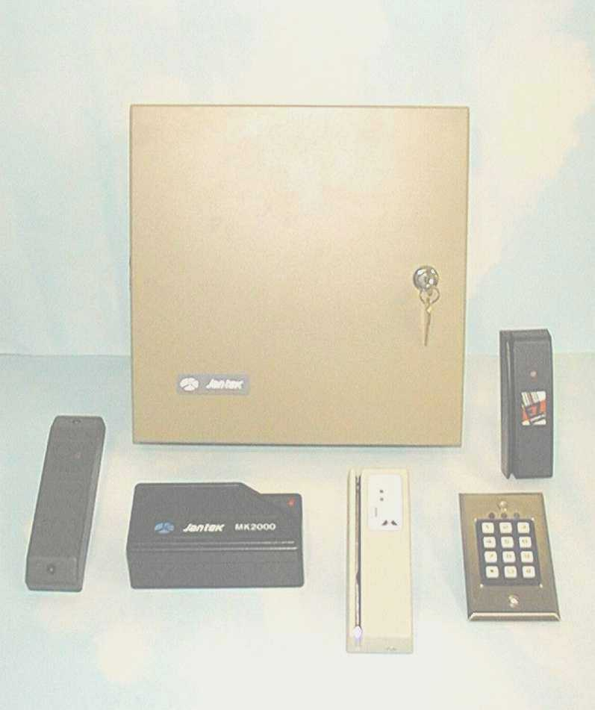
JAS - PC Based Access Control System

JASWIN Access Control Software |  |  | JST 400 Reader Controller
 | Controls multiple JST400s (up to 128 doors) |  | PC Programmable, controls 1 to 4 readers
 | Supports 3,500 users. (Expandable to 8,000) |  | Supports 1,000 users. (Expandable to 2,500)
 | 7 programmable time zones, 2 schedules per zone |  | Daisy chain with other JST400s. (RS232C)  Four form C door access relay.
 | Multi-level password protection. |  | 7 programmable time zones per reader
 | Easy employee database management |  | 3 general purpose time programmable relays.
 | Optional remote auto-dialing feature. |  | 3,000 event history transaction buffer.
 | Office hour auto-open feature |  | Supports card readers and keypad use
 | Programmable company holidays. |  | Supports barcode, magnetic stripe, Wiegand, and proximity readers.

PR-200 Proximity Access Control Reader

- Weather Resistant (Indoor or Outdoor)
- Maximum Read Range: up to 5”
- Easy to Install
- Size: 5.1” x 3.4” x 1”
- Frequency: 125KHz

